Signs of Intelligence: A Neural Network Approach to American Sign Language Detection

Progress Report
Team 2:
Michael Deng, L&S Undergraduate
Chris Yang, L&S Undergraduate
Sharvil Dave, L&S Undergraduate
04/04/2024

So far, our group has set up the github repository, created the google colab notebook, and shared it with each other. We have also downloaded and preprocessed the ASL dataset from Kaggle. What we have left to work on is building, testing, and training the model, evaluating the performance of the model and improving or modifying it as needed. We also need to document our findings and process in the final report, and create the final presentation to communicate our findings and explain our results.

- Intro
  - This project seeks to develop a machine learning model, with a focus on Convolutional Neural Networks (CNNs), to classify images of the American Sign Language (ASL) alphabet. The aim is to facilitate communication for the deaf and hard-of-hearing community by translating ASL gestures into text or speech, thereby enhancing accessibility.
The advancement of American Sign Language (ASL) image classification is crucial for enhancing communication tools for the deaf and hard-of-hearing community. Convolutional Neural Networks (CNNs) have been at the forefront of this research, effectively processing ASL images to recognize static signs with notable success. The ASL Alphabet dataset on Kaggle has been instrumental in this project, providing a rich source of ASL sign images for model training. Pioneering studies, such as those by Daroya in 2018, demonstrate the integration of CNNs with sequence models like LSTMs to capture the dynamic nature of sign language. This project aims to build on these successes by further exploring deep learning techniques to improve the accuracy and generalization of ASL classification, addressing the complexities of both static and dynamic sign interpretation. With the growing need for accessible communication aids, this research holds the potential to make significant impacts in the lives of many.
Our project focuses on enhancing ASL image classification using the Kaggle ASL Alphabet dataset, with a baseline approach employing Convolutional Neural Networks (CNNs) for static sign recognition. To overcome the limitations of existing models in capturing dynamic signs, we plan to incorporate Long Short-Term Memory (LSTM) networks for better temporal analysis. Advanced techniques like data augmentation and transfer learning will also be explored to improve generalization. This integrated approach aims to improve the accuracy and robustness of ASL classification, making communication tools more accessible for the deaf and hard-of-hearing community.
- Method
  - Dataset
    - This dataset is downloaded from the kaggle data set ASL Alphabet. It contains 87,029 data samples partitioned into 87,000 training images, and 29 testing images. Each sample is a 200x200 image of an ASL alphabet character. There is no missing data. Standardization is not required, but we may decide to augment our data with scaled images for improved accuracy on real-world datasets. Similarly, we may decide to augment our dataset with flipped versions of each hand symbol after attempting to train/validate with no augmented images.
    - A in ASL: 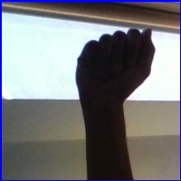
    - B in ASL: 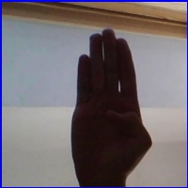
    - C in ASL: 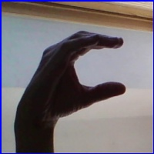
    - Z in ASL: 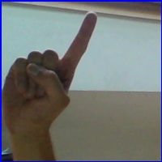
  - Baseline
    - Daroya in 2018, demonstrated the integration of CNNs to classify sign languagee. Inspired by DenseNet solving their vanishing gradient problem, they proposed a deep network for sign language classification, and further implemented real-time classification with a web-camera at up to 100hz. They made use of data augmentation including random rotations, random shifts, shearing, and zooming. (Link below)
  - Proposed Tasks and Preliminary Results
    - Our group has set up the github repository, created the google colab notebook, and shared it with each other. We have also downloaded and preprocessed the ASL dataset from Kaggle. What we have left to work on is building, testing, and training the model, evaluating the performance of the model and improving or modifying it as needed, documenting the findings and process in the final report, then creating the final presentation to communicate our findings and explain our results. We will evaluate the results using a confusion matrix and finding the accuracy of our model.
  - TODO
    - Before the final report, we still have to build, test, and train the model, evaluate the performance of the model and improve or modify it as needed depending on our results, document the findings and process in the final report, then create the final presentation to communicate our findings and explain our results.
  - References
    - @misc{https://www.kaggle.com/grassknoted/aslalphabet_akash nagaraj_2018,
title={ASL Alphabet},url={https://www.kaggle.com/dsv/29550}, DOI={10.34740/KAGGLE/DSV/29550},
    - Daroya, Rangel & Peralta, Daryl & Naval, Prospero. (2018). Alphabet Sign Language Image Classification Using Deep Learning. 0646-0650. 10.1109/TENCON.2018.8650241.
  - Team Contributions
    - Sharvil Dave - Background, Overview, Baseline, Git Set Up, 33.3%
    - Christopher Yang - Abstract, Proposed tasks and preliminary results, TODO 33.3%
    - Michael Deng - Overview, Datasets, Intro 33.4%

